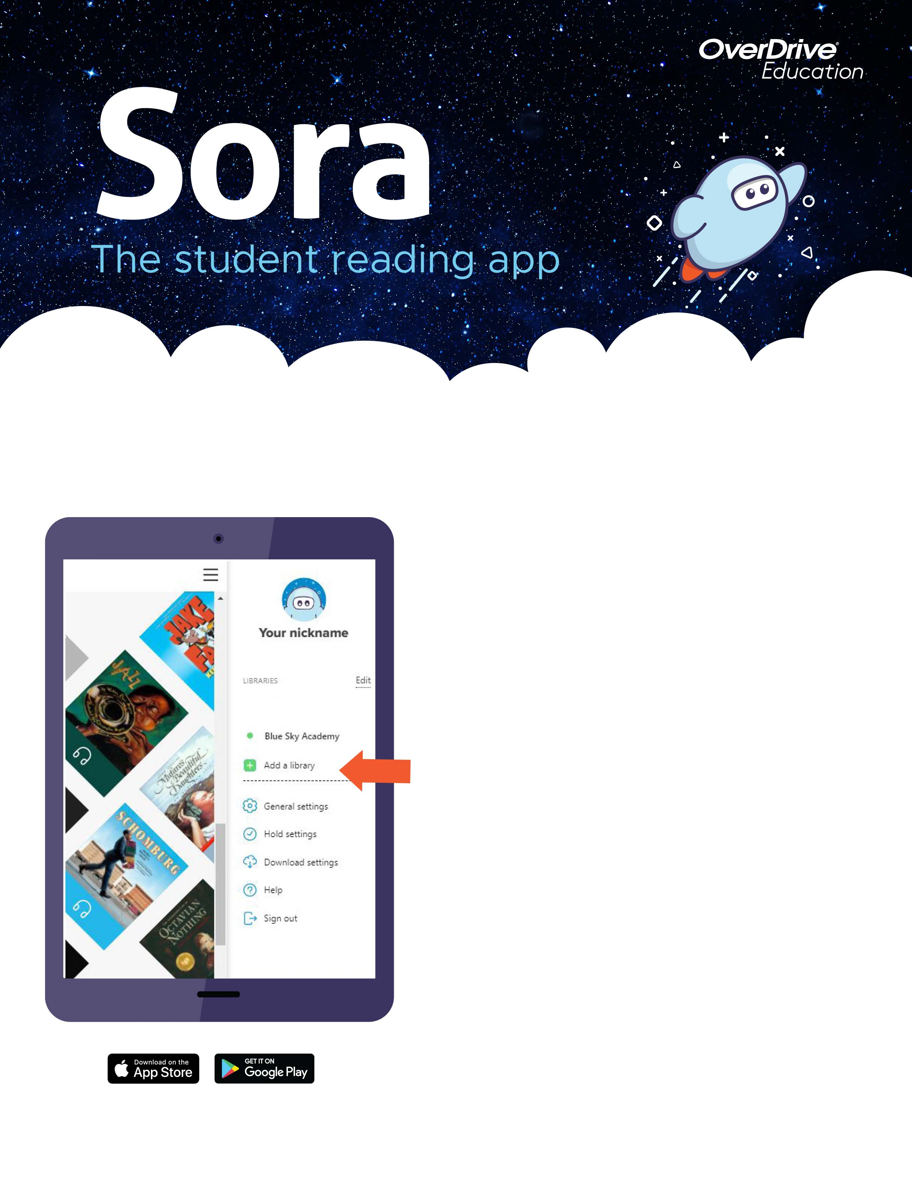
1. Install the Sora app from the Apple App Store or Google Play Store, or go to soraapp.com.

2. In Sora, login the way you login to other school apps.

3. Under your Profile, select + Add a library
and enter Indianapolis Public Library.

4. Click Borrow or Place hold on any title to be prompted to sign-in to the public library.
5. Sign in with your library card – first time only. After that Sora will remember you!

TIP: Ask your school library manager for your library card number.
Here’s how to access titles from the library through Sora:

Sora has graphic novels, audio books, and e-books from
The Indianapolis Public Library

